- Dec and RA grids made, Full Score
- (Smallest Circle, Full Score; Medium Circle, Half Score; Largest Circle, Quarter Score)
- (Smallest Circle, Full Score; Medium Circle, Half Score; Largest Circle, Quarter Score)
- (Smallest Circle, Full Score; Medium Circle, Half Score; Largest Circle, Quarter Score)
- Galactic plane inside the yellow line : Full Score
Galactic plane crosses the yellow line : Half Score
- ± 2º , Full Score
± 5º, Half Score

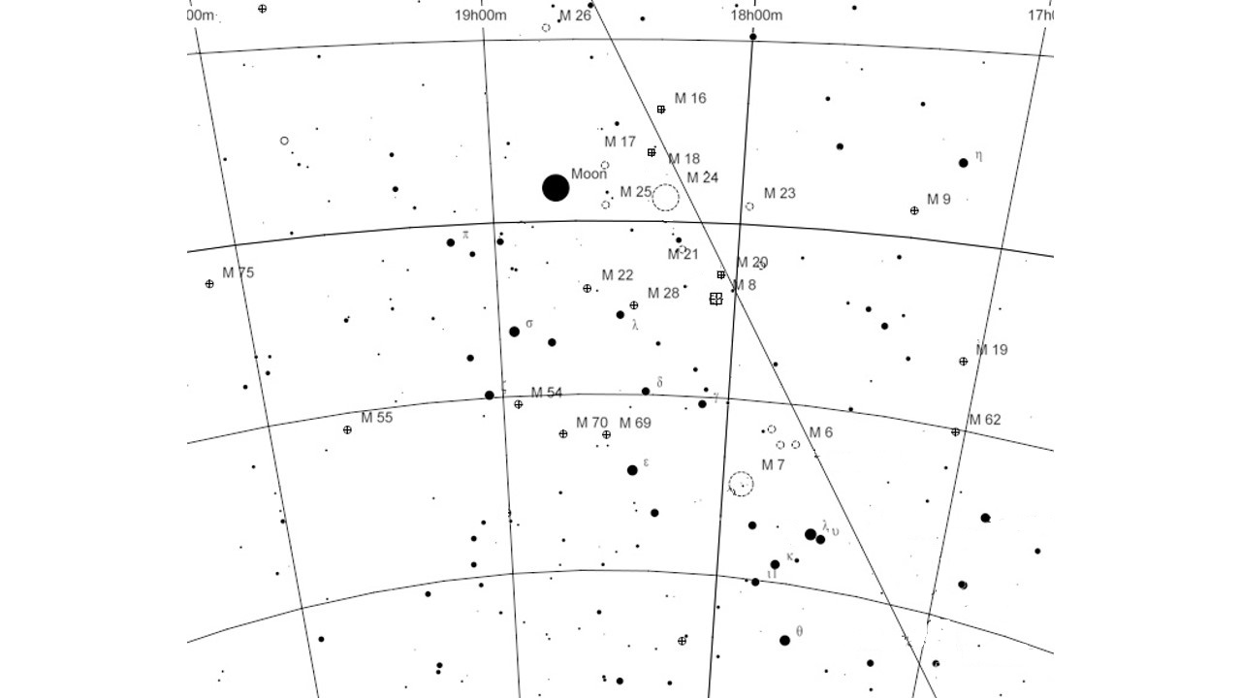
18h 36m 56.84s
-20º00’
-10º00’
Nova Sagitarii
Galactic Plane
-40º00’
-30º00’

4

-28º 55’ 39.8”

2

1
5

3

Marking Messier Object
18h 36m 56.84s
-20º00’
-10º00’
Nova Sagitarii
Galactic Plane
-40º00’
-30º00’

-28º 55’ 39.8”

Messier Object
Messier | Magnitudo | size (')
7 | 3.3 | 80
6 | 4.2 | 15
25 | 4.6 | 32
22 | 5.2 | 24
23 | 5.5 | 27
8 | 5.8 | 90
21 | 5.9 | 13
16 | 6 | 35
17 | 6 | 46
20 | 6.3 | 29
62 | 6.6 | 14
20 | 6.9 | 11
18 | 6.9 | 9
55 | 7 | 19
19 | 7.2 | 13
69 | 7.7 | 7
54 | 7.7 | 9
9 | 7.9 | 9
70 | 8.1 | 7
24 | 11 | 5

-20º00’
-10º00’
Nova Sagitarii
Galactic Plane
-40º00’
-30º00’
18h 36m 56.84s

-28º 55’ 39.8”

